**5. The Road to Emmaus**

**Reading:** Luke 24:30-33, 35

Joining them at the super table, Jesus took some bread and gave thanks. Then he broke some off and gave it to them. Just then the men were allowed to recognise him. But when they saw who he was, he disappeared. The said to each other, “when he talked to us on the road, it felt like a fire burning in is. How exciting it was when he explained to us the true meaning of the Scriptures!”

So the two men got up then and went back to Jerusalem. There they found the followers of Jesus meeting together.

The two men told what had happened on the road. They talked about how they recognised Jesus when he shared the bread with them.

**Thought about the reading**

This story took place on Easter Sunday. Jesus had risen from the dead, but no-one had seen him yet. Two of his followers decided they would go home to Emmaus. It was a long walk, and they were very sad because they knew Jesus had died on the cross.

While they were walking on the road, Jesus joined them, but they did not recognise him. He talked to them about the Scriptures and explained why he had to die. When they got to Emmaus, they asked Jesus to have supper with them. Jesus said thank you for the food and broke the bread so he could share it out. That is when they saw that it was Jesus! At that moment, he disappeared! They were so excited. They had seen Jesus! He was alive! They set off for Jerusalem straight away to tell the other followers.

These two followers were eyewitnesses, and they told the other disciples what they had seen. They didn’t even stop to finish their supper.

**Prayer**

Lord Jesus, thank you that these two followers were so excited to know that you were alive that they went straight back to Jerusalem to tell everyone.

Please help me to be as excited to know that you are still alive. Please help me to be a witness and tell other people this wonderful news.

Amen

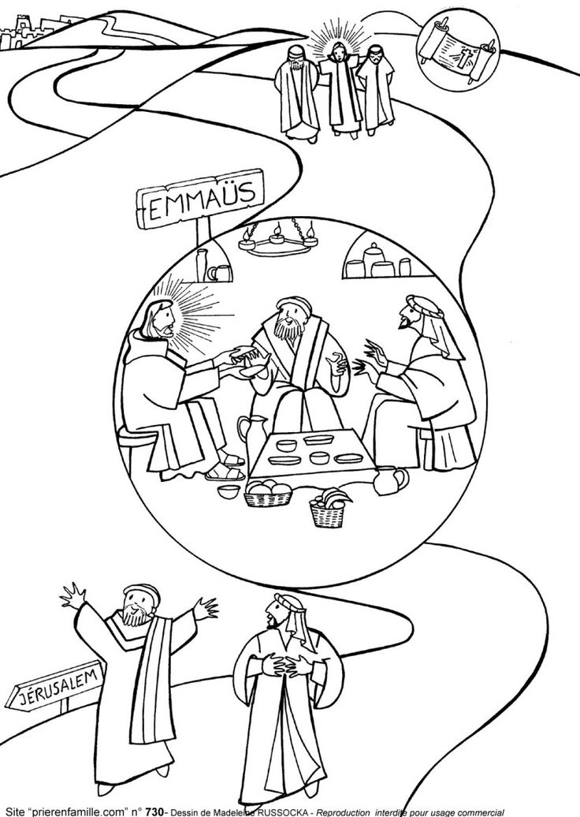

**Cambridge Causeway**

Summer 2021

Bible Study notes

**Eyewitnesses**

**5. The Road to Emmaus**

By Chrissy Cole